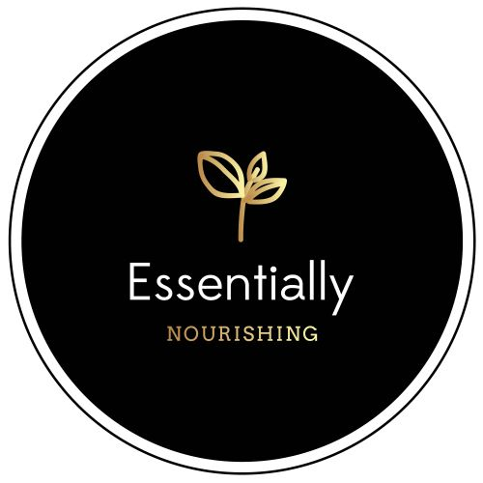

MENU

GRANOLA

Paleo Granola
1.5 cups (12 ounces) $20
Regular or Vanilla

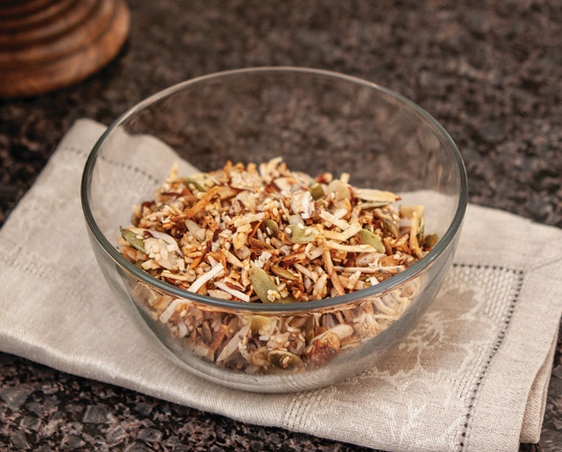
Cluster Granola (More of a cluster granola with a yummy crust, very crunchy)
2 cups $20

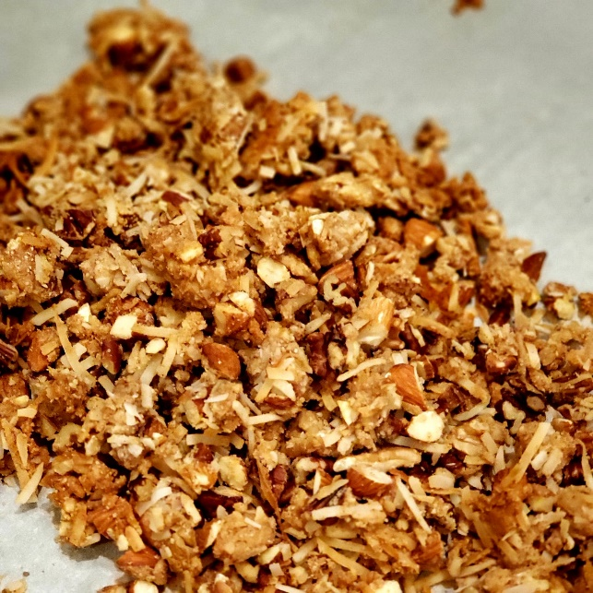

PB Oatmeal Granola (More of a cluster granola with a yummy pb maple syrup crust)
3 cups $25

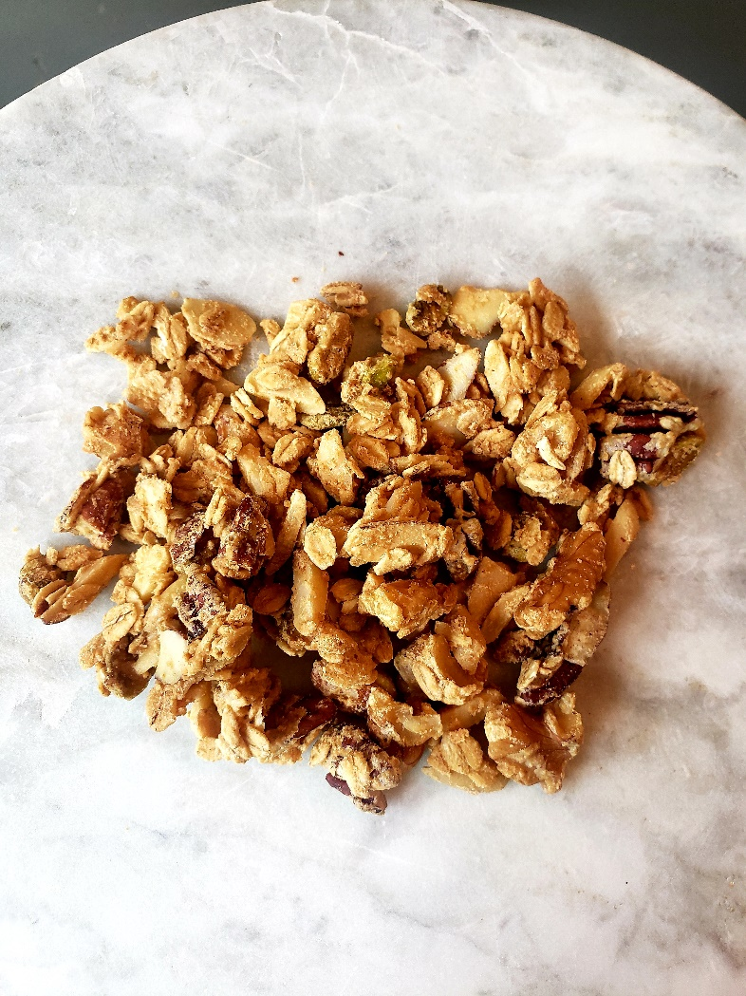

BLONDIES/BROWNIES

Blondies
8 blondies $20, 16 blondies $40
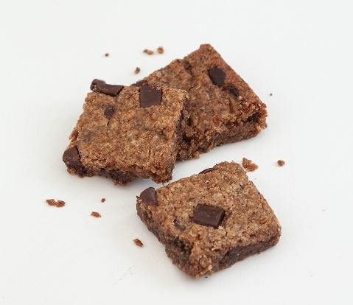

Peppermint Brownies
8 brownies $20, 16 brownies $36

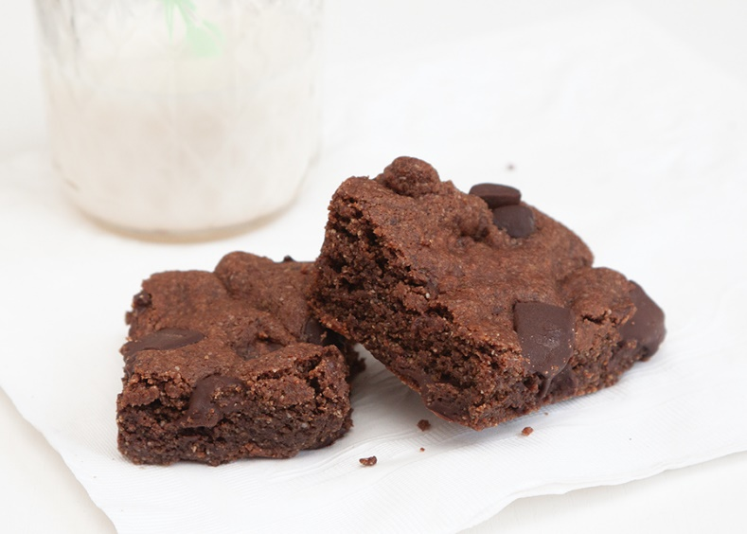

Chocolate Peanut Butter “Smush” Brownies (Mushy Brownie w/Peanut Butter swirl)
8 brownies $28, 16 brownies $48

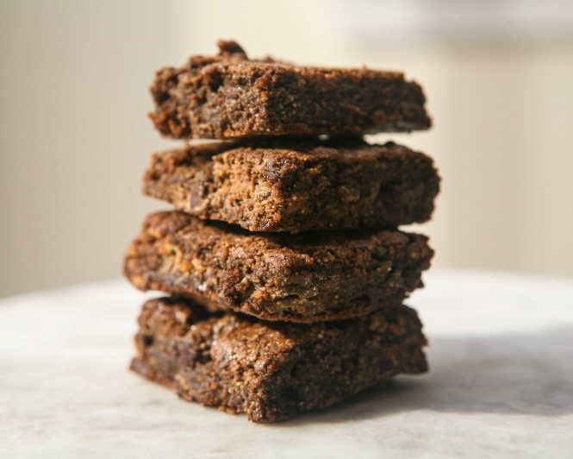

COOKIES
Thin Mints
20 cookies $40
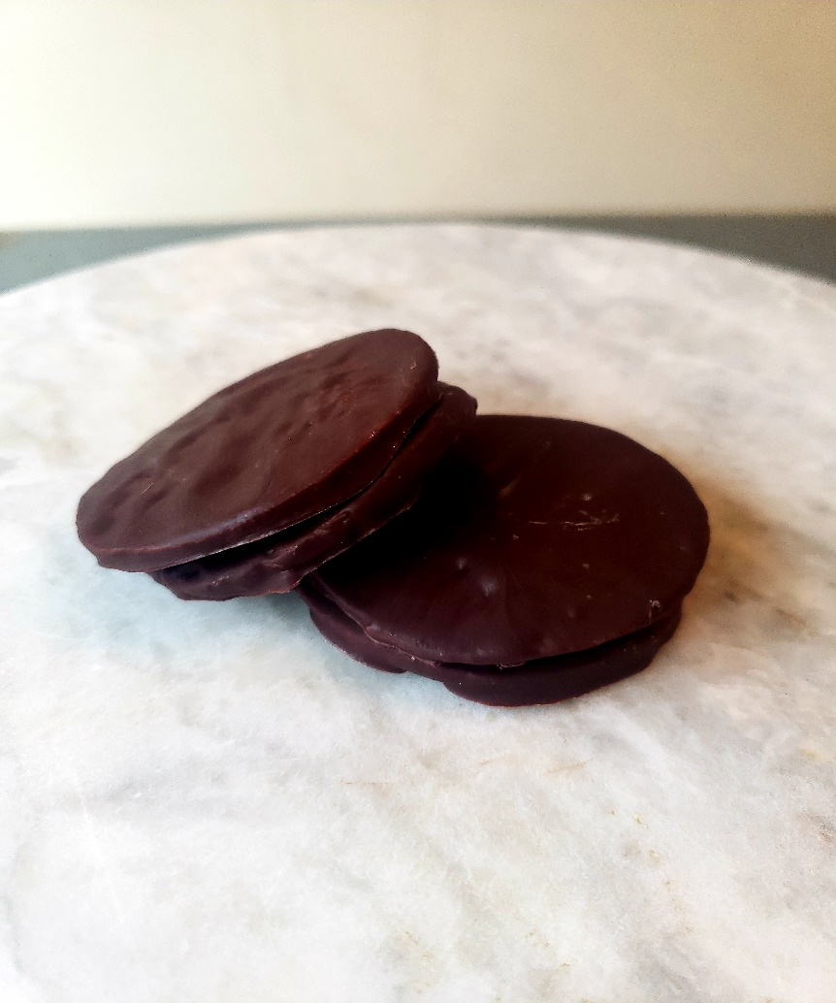

Snickerdoodles
12 cookies $22, 24 cookies $40

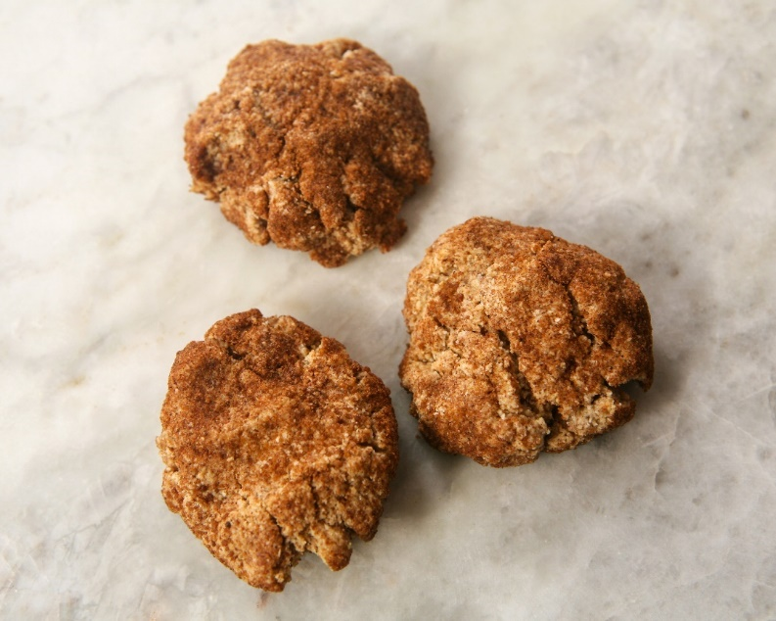

Lemon Cookies
8 cookies $22, 16 cookies $40
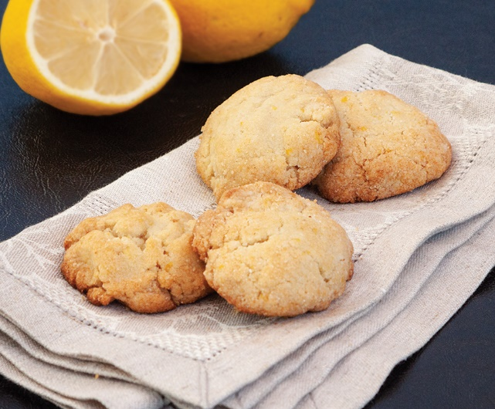
Chocolate Peppermint Pecan Cookies
12 cookies $25, 24 cookies $45

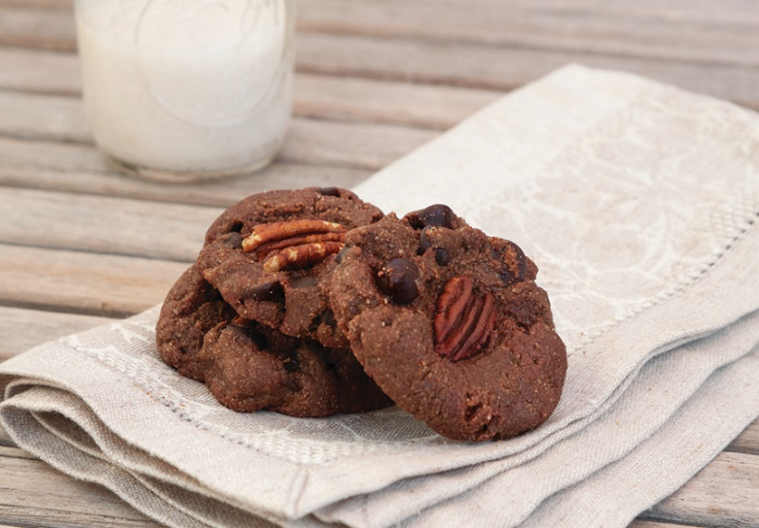

Peanut Butter Chocolate Chunk Cookies
10 cookies $24, 20 cookies $42

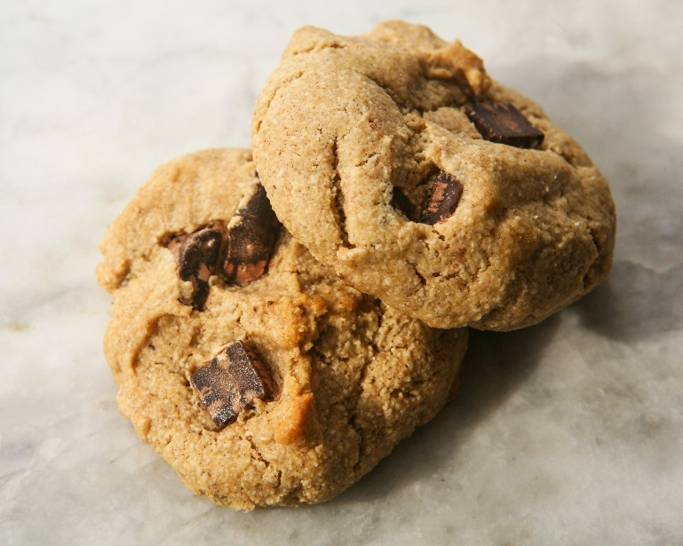
Pecan Shortbread
15 cookies $24, 30 cookies $44
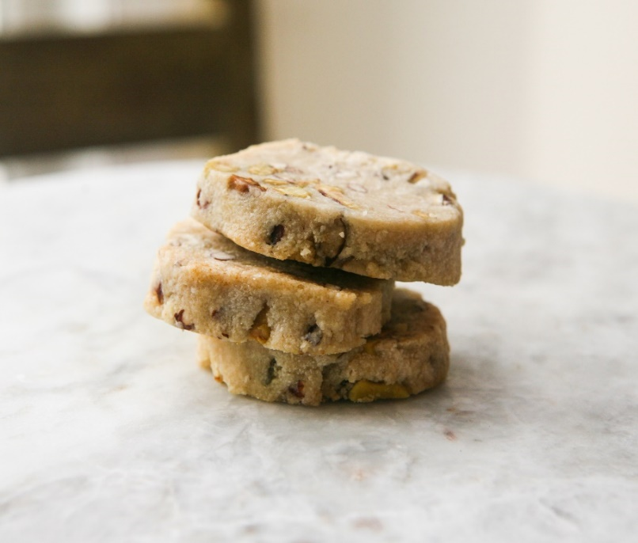

Vanilla Cookies with Chocolate Glaze
15 cookies $30, 30 cookies $55
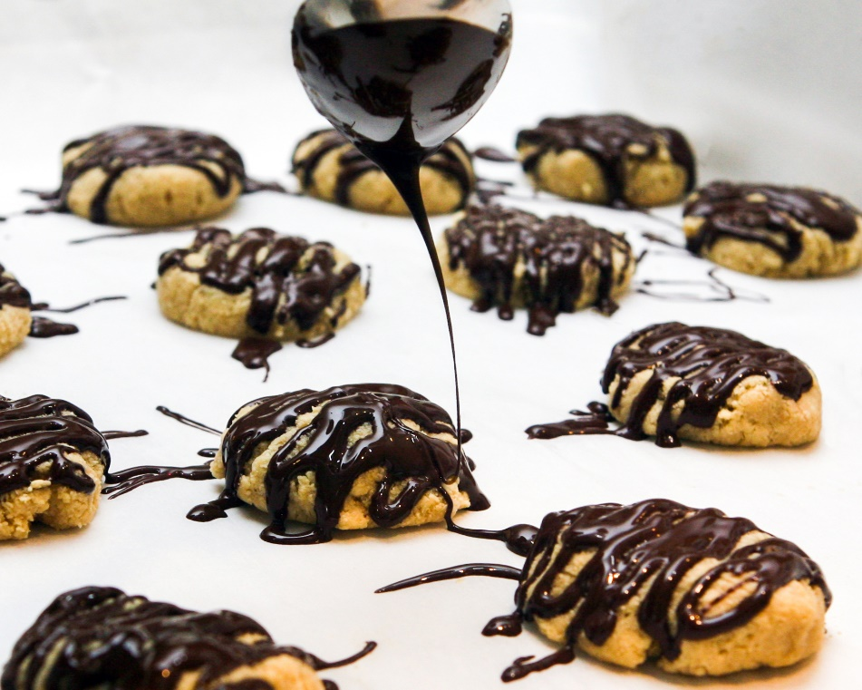
New Choc Chip Shortbread Cookies
16 Cookies $34
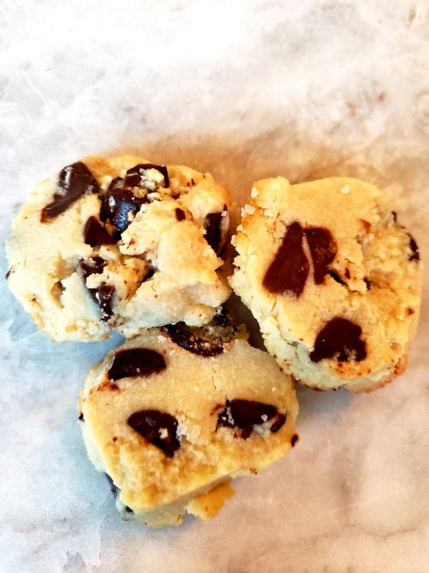

Vanilla Struesel Cookies
12 Cookies $30
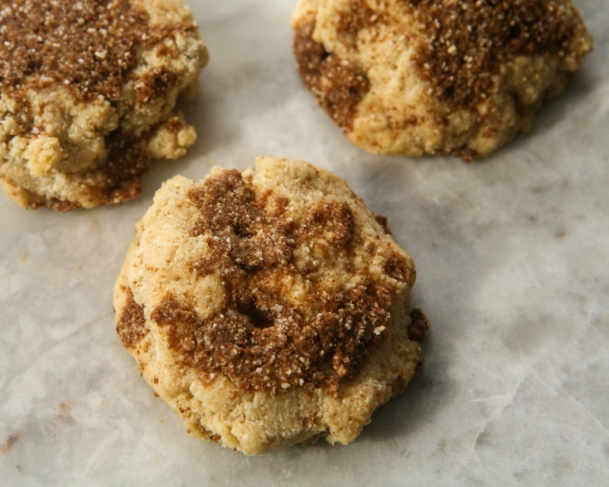

Chocolate Chunk Wild Orange Cookies
12 cookies $25, 24 cookies $45

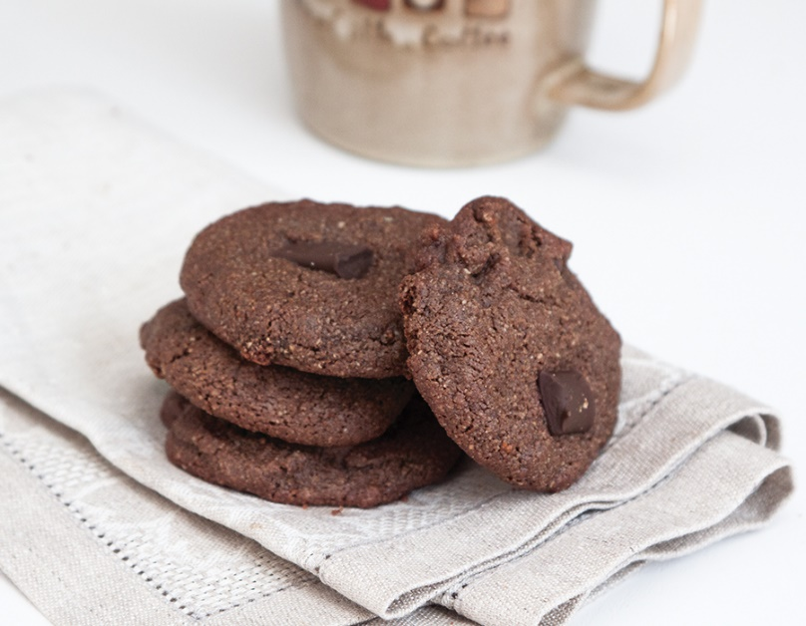
Chocolate Chip Pecan Cookies (Option for only chocolate chips)
15 Cookies $38, 30 cookies $68
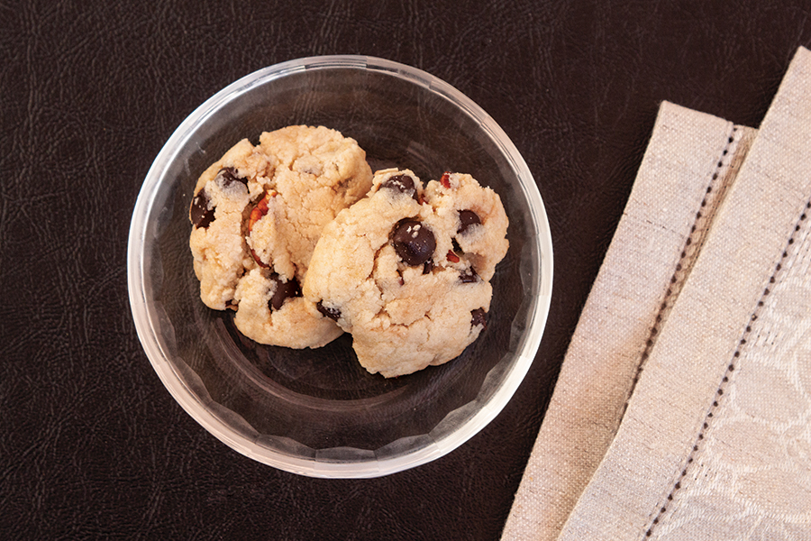

Chocolate Dipped Peanut Butter No Bake
10 cookies $25
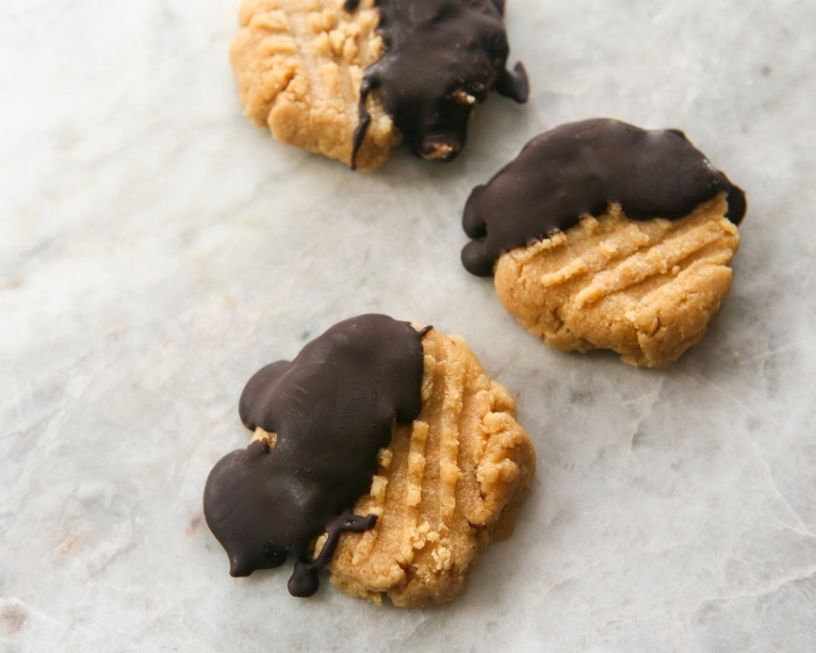

CHEWY CHOCOLATE CHIP COOKIES
9 cookies $22
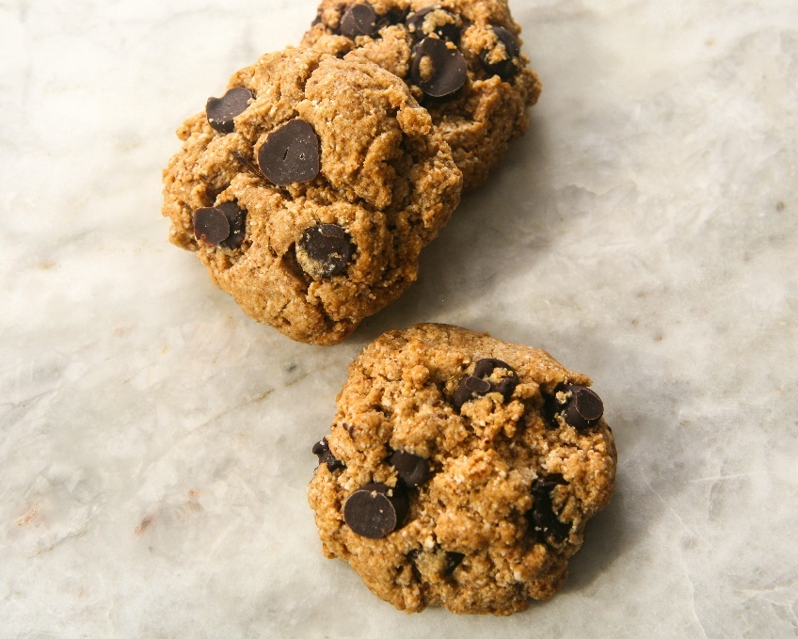
Chocolate Cookie Crumb
12 Cookies $28

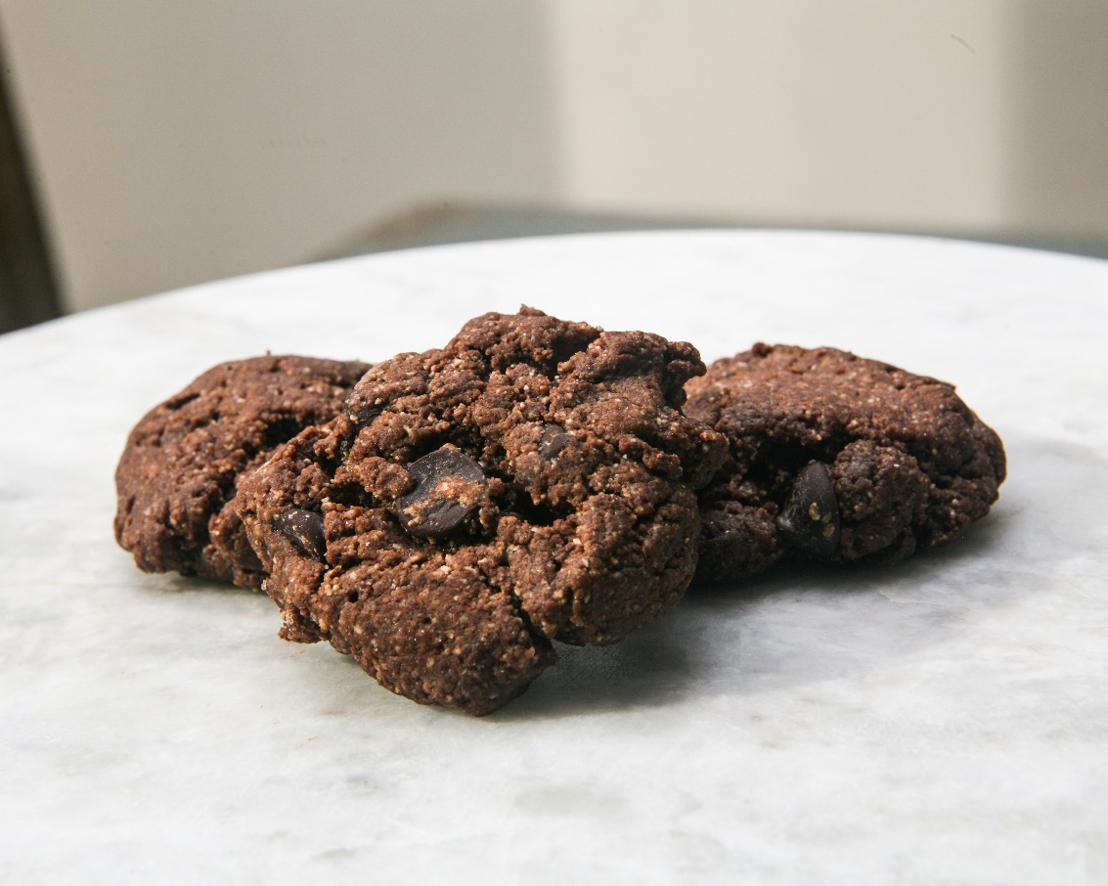

MUFFINS/BARS/ENERGY BALLS

Cinnamon Coffee Crumb Muffins
5 Muffins $15, 10 Muffins for $25
Mini Muffins (pic below) 10 for $15, 20 for $25

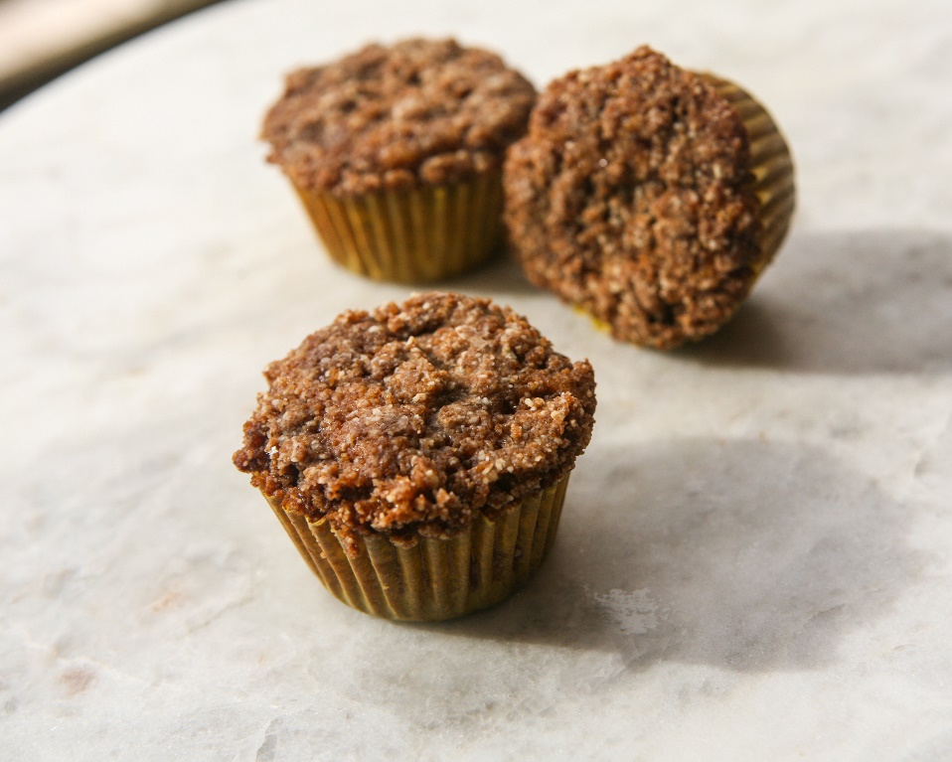

Lemon Poppy Muffins
6 Muffins $18, 12 Muffins $34
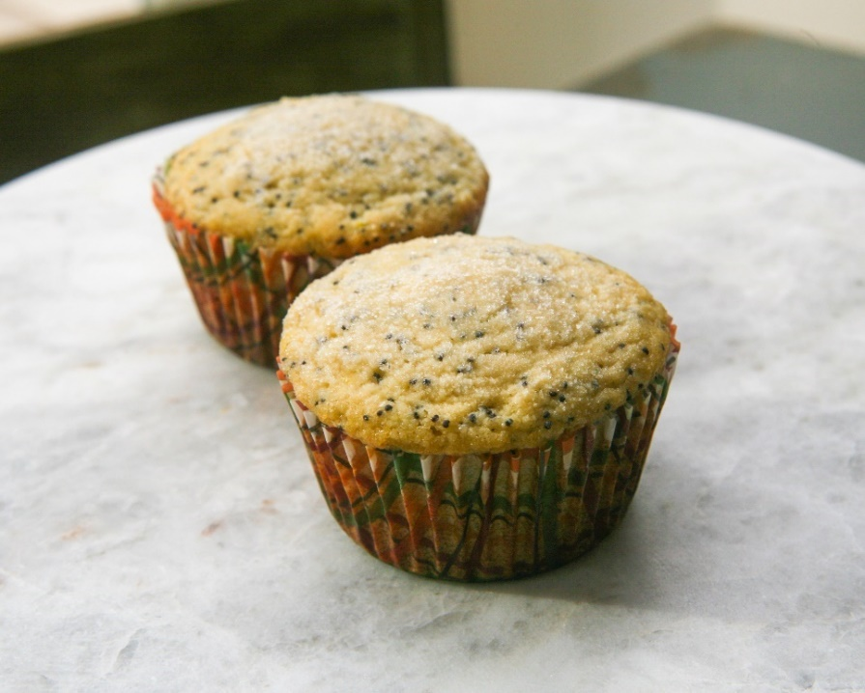

Chocolate Tahini Banana Muffins
6 Muffins $20, 12 Muffins $38

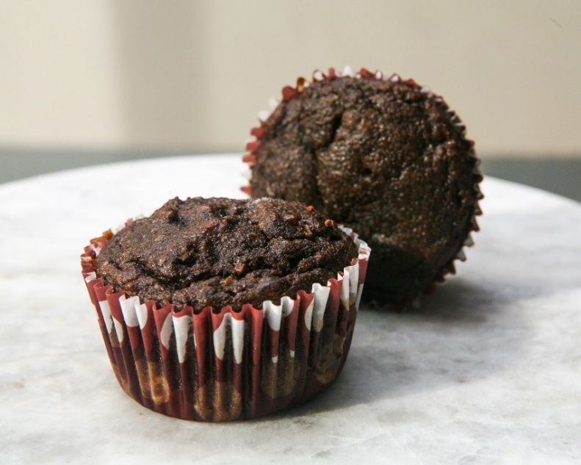
Chocolate Chip Muffins (nut free)
18 Mini Muffins $36
12 Muffins $38

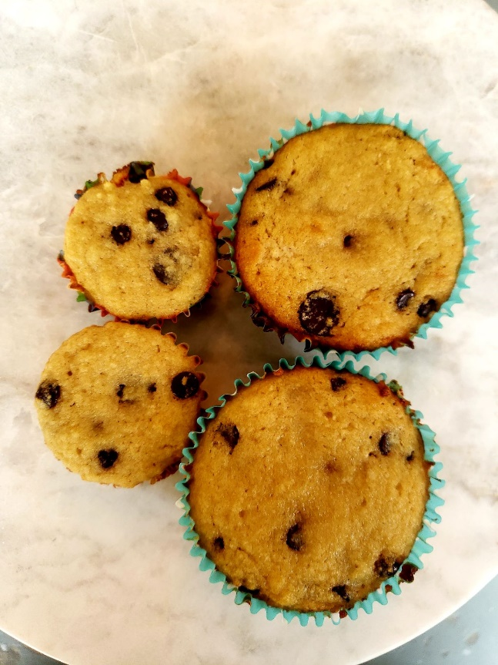

Banana Choc Chip Muffins w/roasted pecans
12 Muffins $36

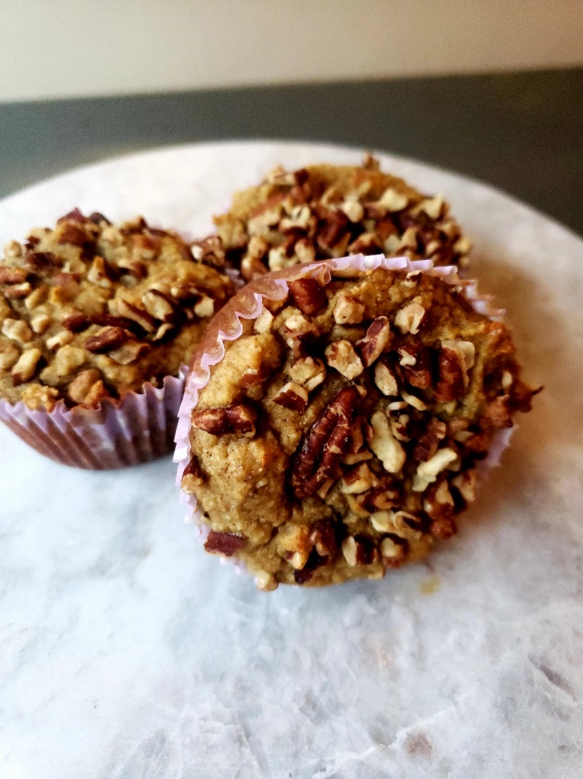

New Cinnamon Swirl Banana Muffins
9 Muffins $27

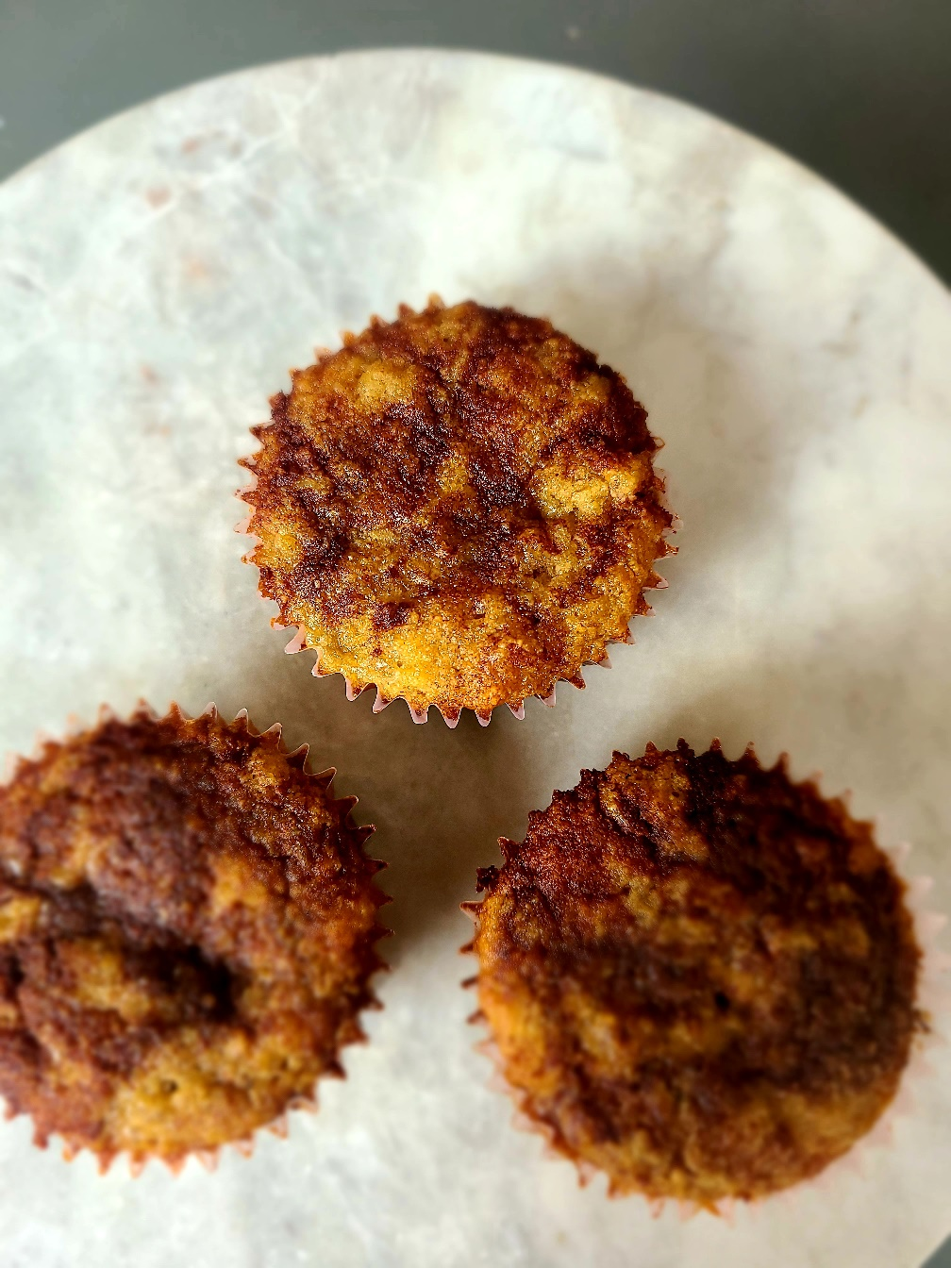

New Double Chocolate Muffins
12 Muffins $40

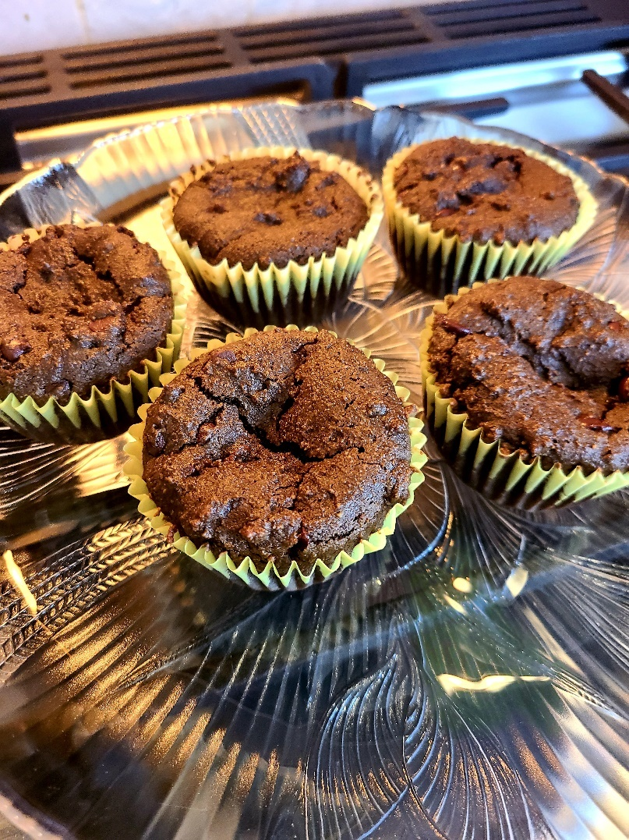

Cookie Dough Balls w/ Chocolate Glaze
10 balls for $20, 20 balls for $38

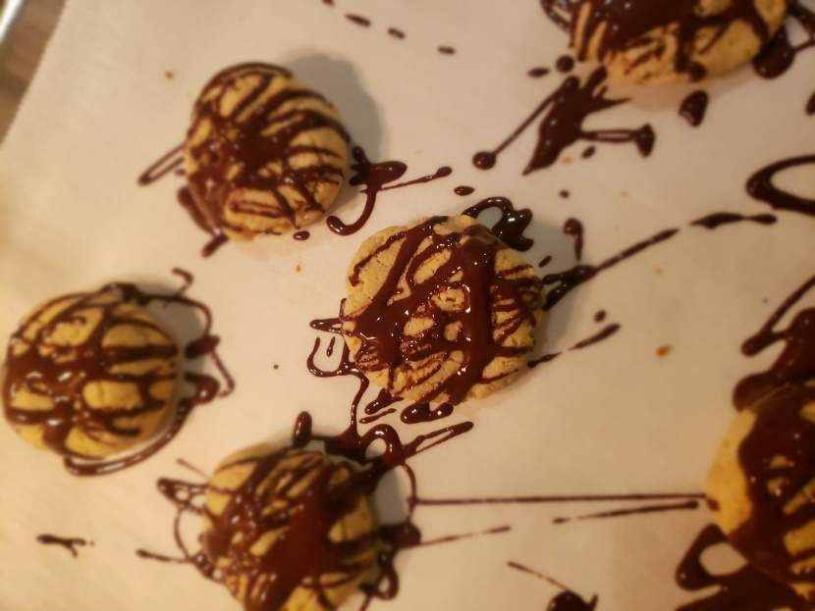

TWIX BARS
12 bars for $28

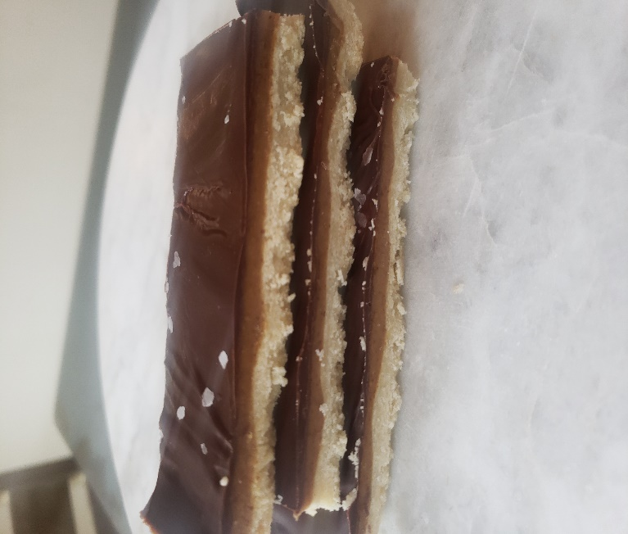

Berry Crumb Bars
8 Squares $25

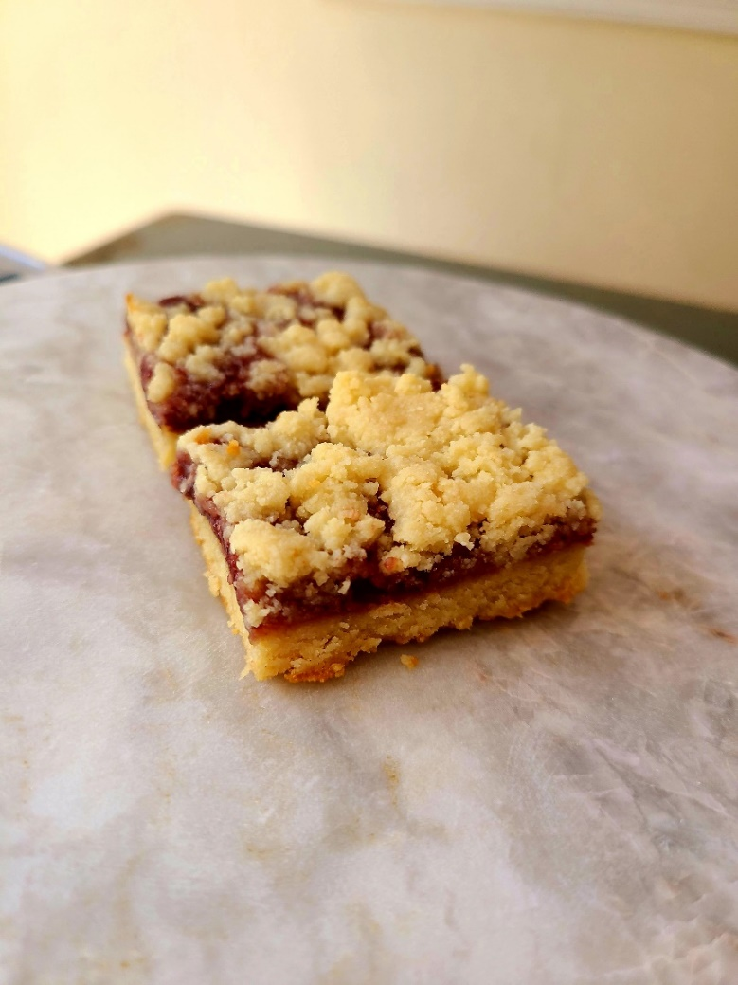

New Apple Pie Bars
12 Bars $36
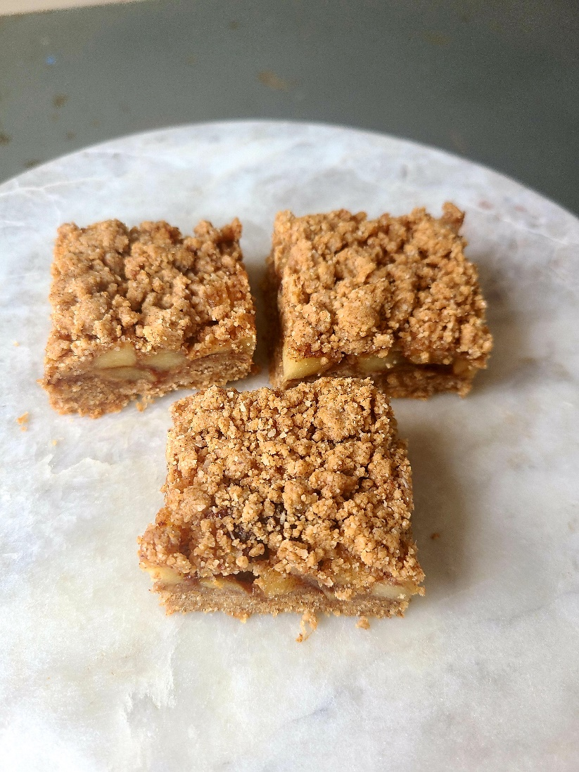

Coffee Cake Squares
8 Squares $20

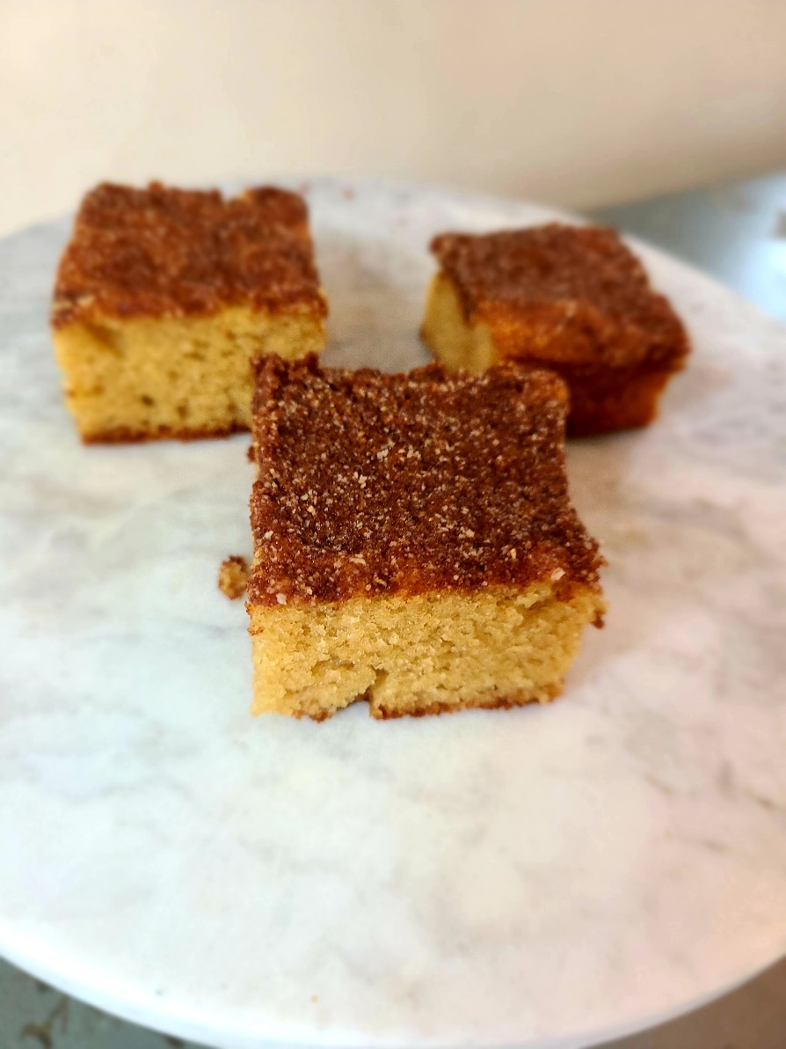

New Healthy Snickers Bars
14 Bars $42
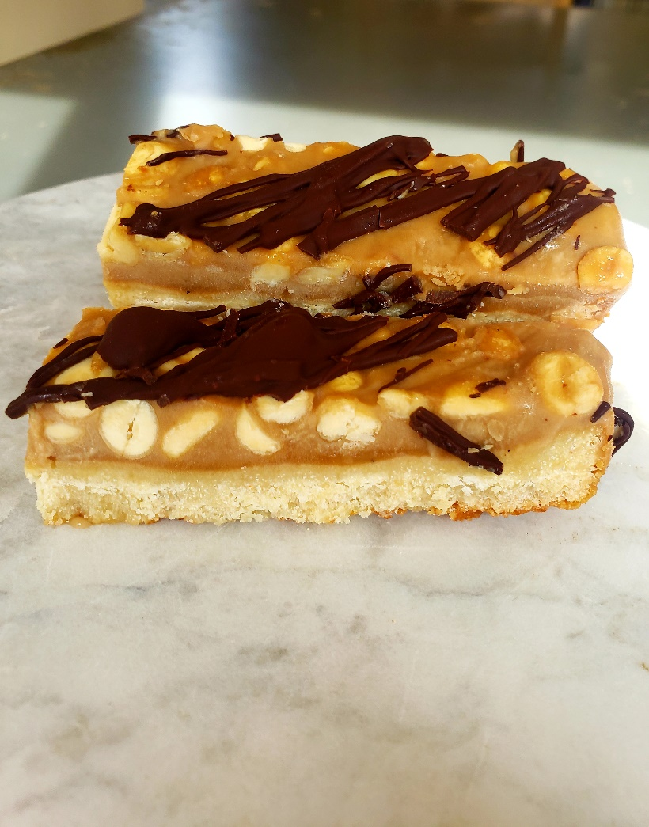

PB Oatmeal Choc Chips Bars
8 Bars $24, 16 Bars $42

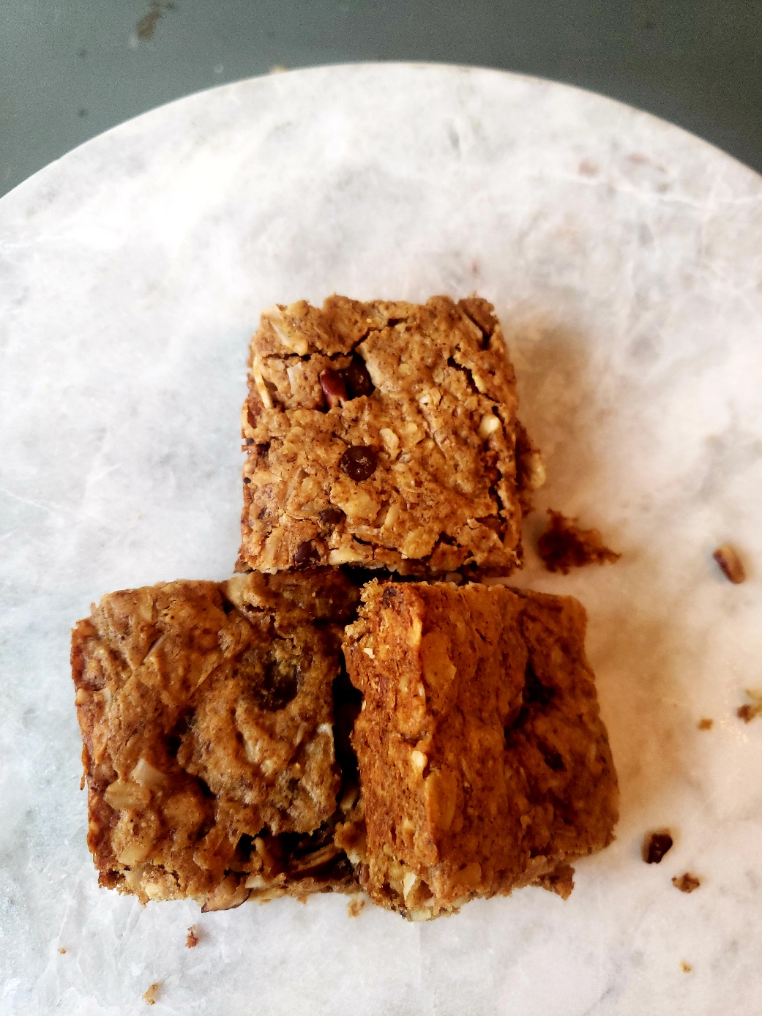

“No Bake” Oatmeal Energy Balls
10 Balls $20

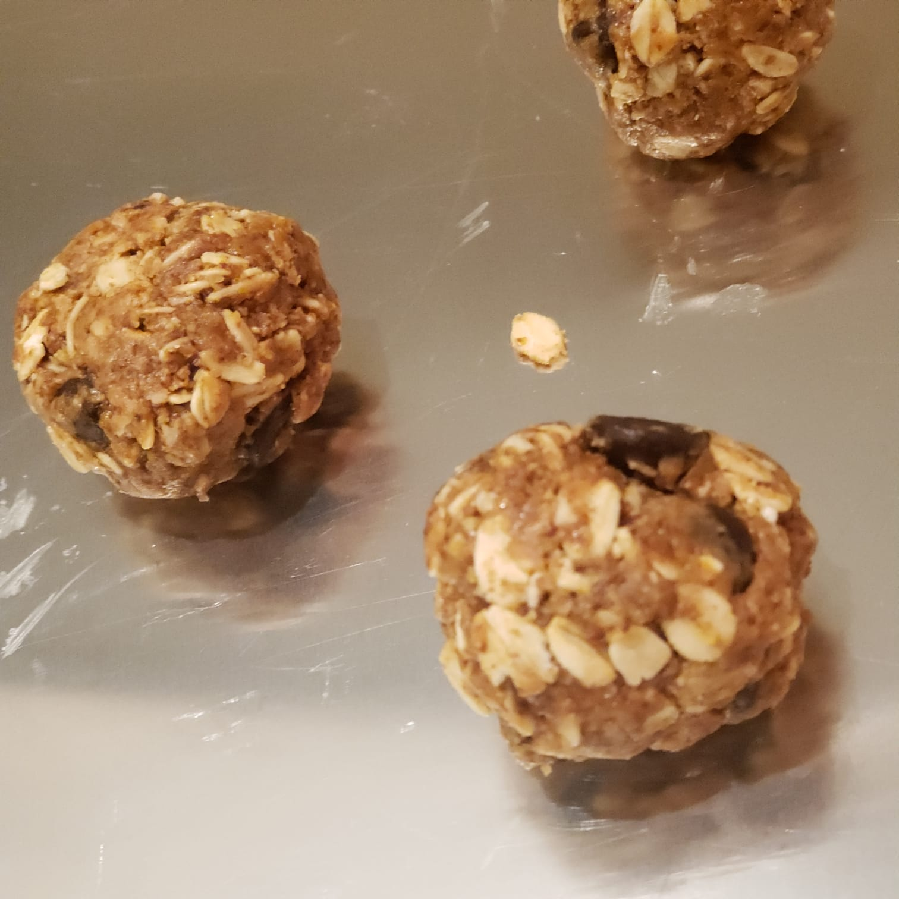

Chocolate Peanut Butter Puff Balls (Crunchy pb choc balls with quinoa puffs)
8 balls $20

